**CK Metrics**

**CK Metrics Suite**

**Five Projects links**

**Spring Boot:** [**https://github.com/spring-projects/spring-boot**](https://github.com/spring-projects/spring-boot)

**Jdbi :** [**https://github.com/jdbi/jdbi/tree/master**](https://github.com/jdbi/jdbi/tree/master)

**Ehcache:** [**https://github.com/ehcache/ehcache3/tree/master**](https://github.com/ehcache/ehcache3/tree/master)

**OpenPDF :** [**https://github.com/LibrePDF/OpenPDF/tree/master**](https://github.com/LibrePDF/OpenPDF/tree/master)

**Spring Framework :** [**https://github.com/spring-projects/spring-framework**](https://github.com/spring-projects/spring-framework)

**Objective**

The aim of this project is to explore and determine the CK Metrics Suite for a selection of five projects sourced from the GitHub platform. This undertaking involves an in-depth analysis and investigation into these projects' codebases to extract valuable insights and key metrics related to their complexity and maintainability.

**Data Set**

**Spring Boot**

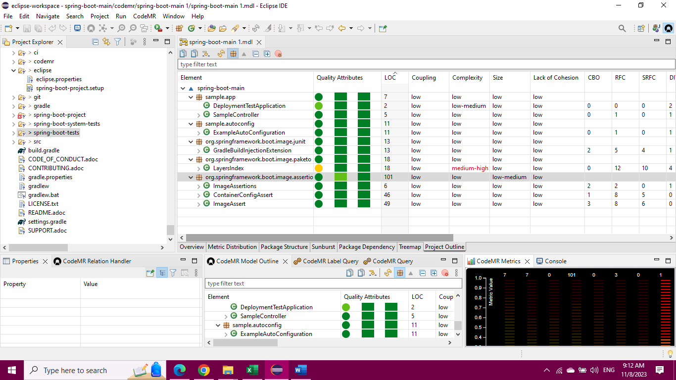

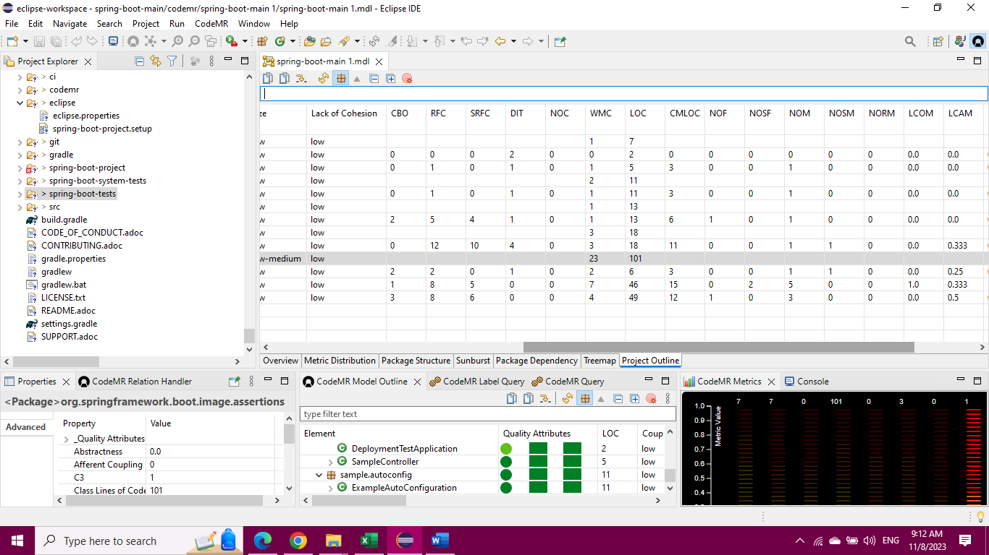

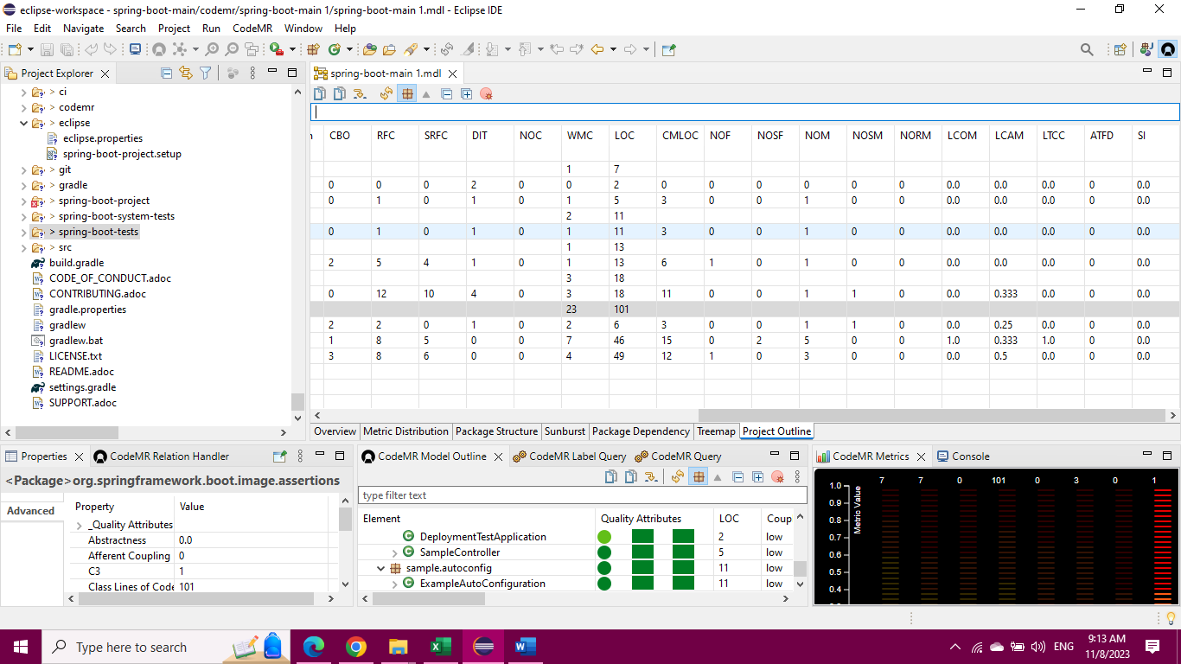

**JDBI**

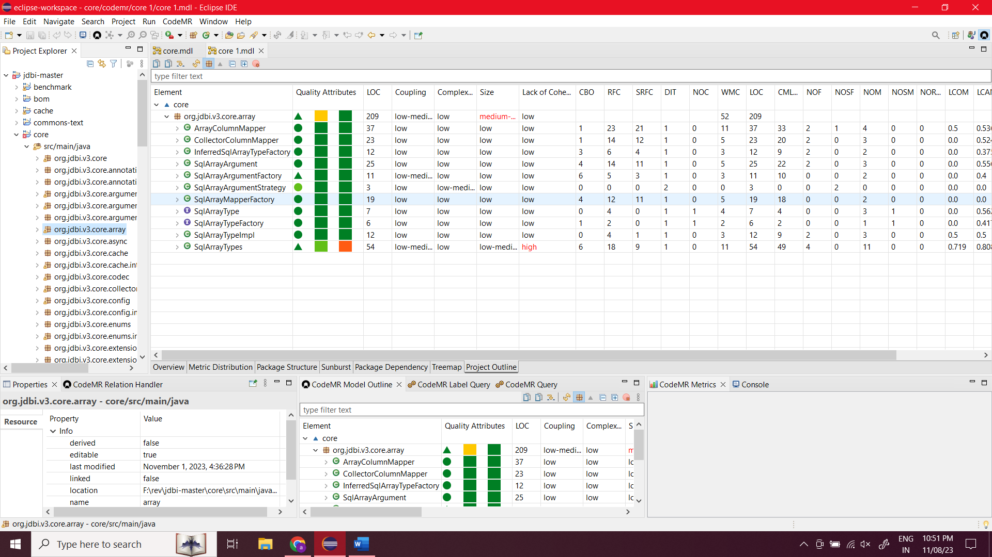

**Ehcache**

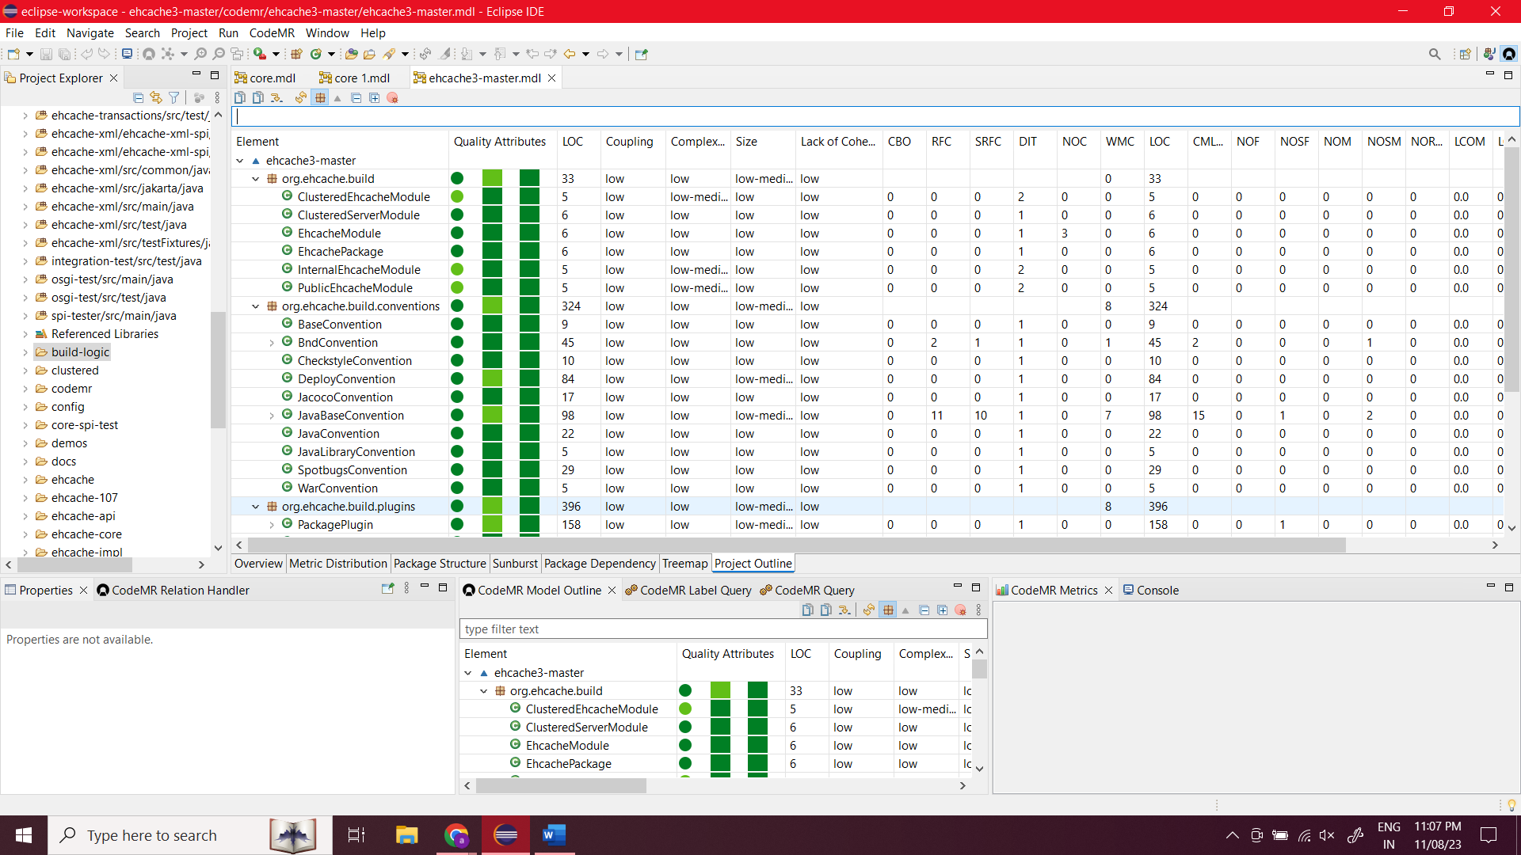

**OpenPDF**

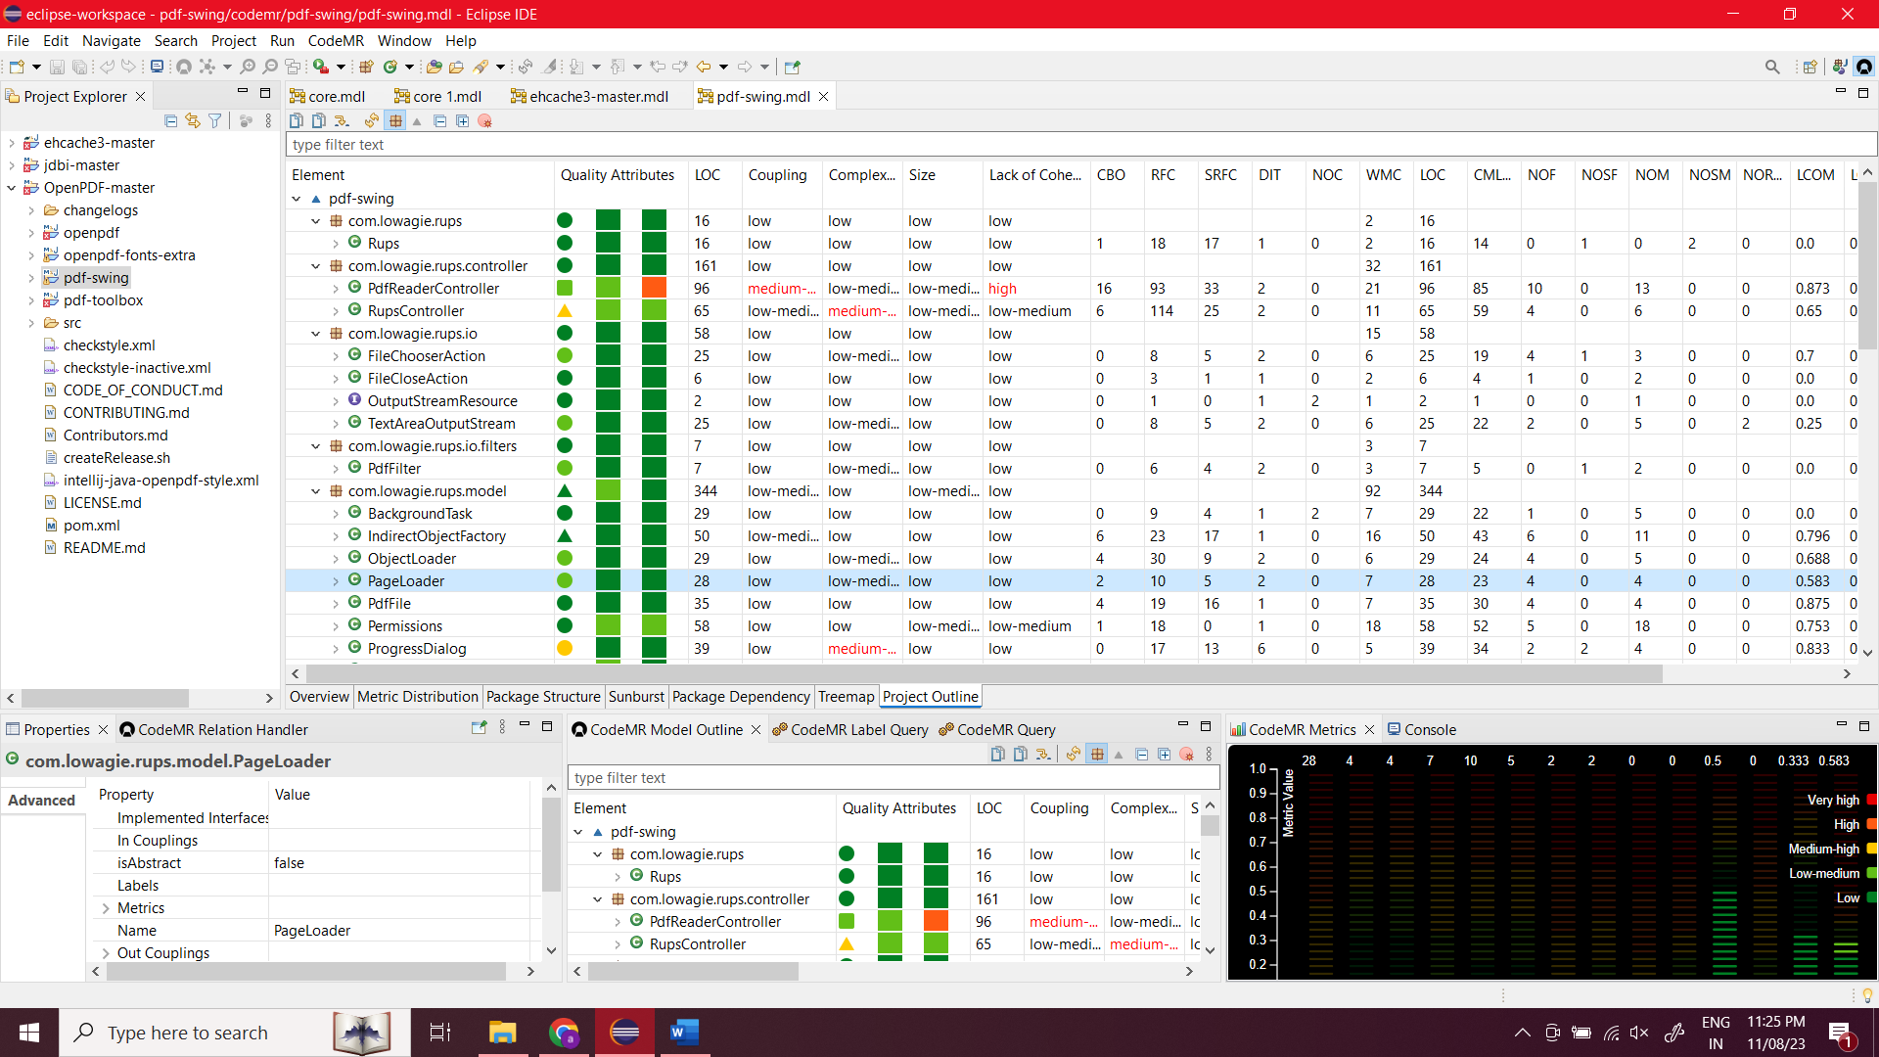

**Spring framework**

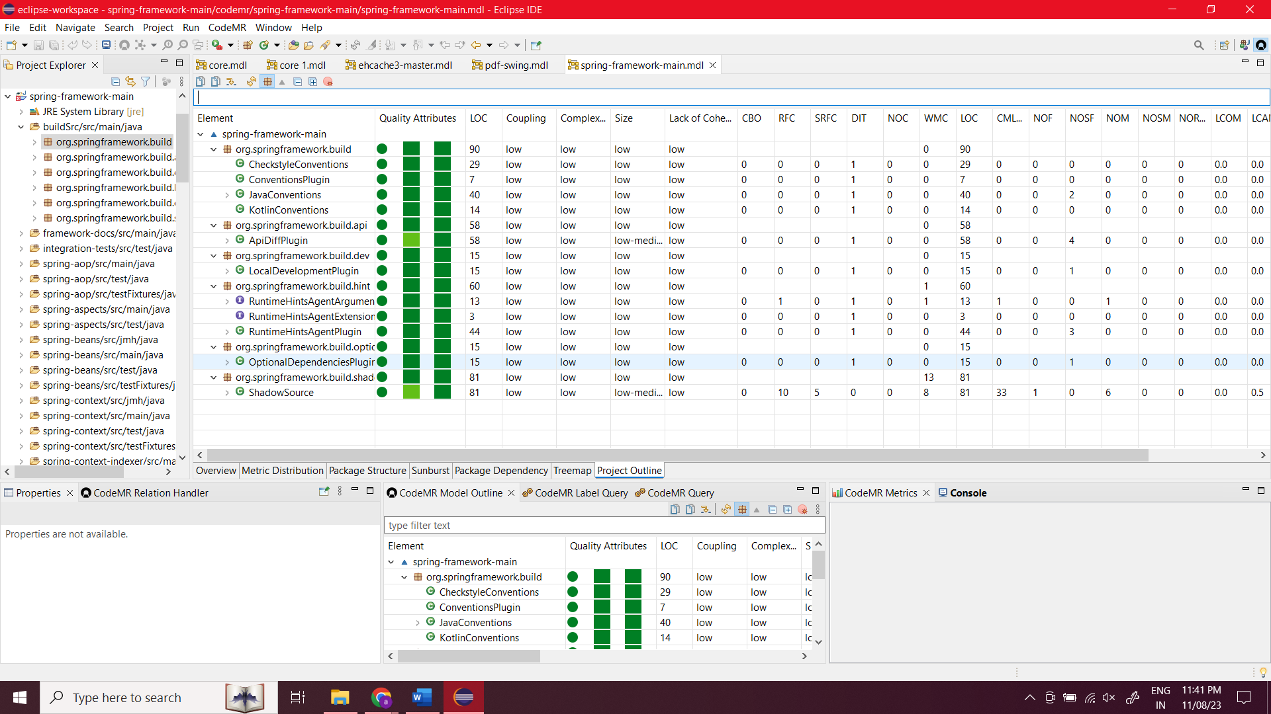

Weighted Methods per Class (WMC): This metric provides insights into the development and testing workload associated with a class by considering both the number of methods it contains and their respective complexities. It aids in understanding the overall class complexity.

Depth of Inheritance Tree (DIT): DIT measures the maximum length from a particular node to the root within an inheritance tree. This metric serves as an indicator of the intricacy of an object-oriented design, with deeper trees reflecting more complex hierarchies.

Number of Children (NOC): NOC signifies the count of immediate subclasses that a class has. This metric plays a crucial role in influencing code reusability and abstraction, highlighting the relationships between classes.

Coupling Between Object Classes (CBO): CBO assesses the degree of interconnection or coupling between different classes. This metric is essential in gauging the complexity involved in making modifications to the code and conducting testing.

Response for a Class (RFC): RFC quantifies the potential methods that may be executed in response to a received message within a class. It sheds light on the effort required for testing and maintaining the class.

Lack of Cohesion in Methods (LCOM): LCOM evaluates the cohesion or similarity of methods within a class by examining their access to instance variables. A higher LCOM value indicates lower cohesion, suggesting that methods within the class are less related in their functionality.

**Tools**

**Eclipse IDE**:

**Integrated Development Environment (IDE)**: Eclipse is a widely used open-source IDE primarily used for Java development, but it supports multiple programming languages through plugins. It provides a comprehensive set of tools for coding, debugging, and testing software.

**Features**: Eclipse offers features like code completion, syntax highlighting, debugging tools, version control integration, and a wide range of plugins for various programming languages and frameworks.

**Platform**: Eclipse is a cross-platform IDE, meaning it can run on multiple operating systems such as Windows, macOS, and Linux.

**Community and Support**: It has a large and active community, which means there are many online resources, forums, and tutorials available for help and support.

**CodeMR**:

**Code Quality Analysis Tool**: CodeMR is a tool that provides static code analysis for various programming languages, including Java, Scala, and Erlang. It helps developers analyze code for potential issues, maintainability, and other metrics.

**Features**: CodeMR typically offers features like code complexity analysis, dependency analysis, code smell detection, and other metrics that help developers maintain high-quality code.

**Purpose**: The primary purpose of CodeMR is to assist in improving the quality and maintainability of codebases.

**Integration**: It can often be integrated with IDEs and continuous integration tools to provide real-time feedback on code quality during development.

**Usage**: CodeMR is particularly useful for large and complex codebases, where maintaining code quality and structure can be challenging.

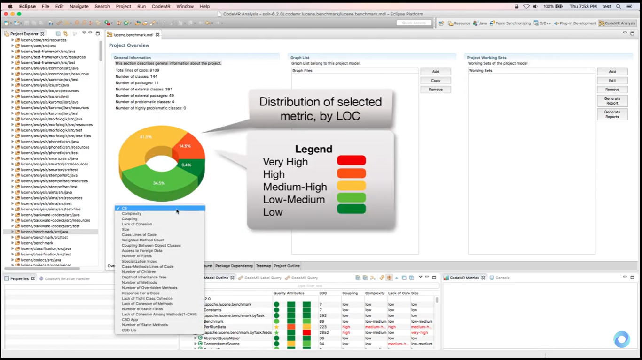

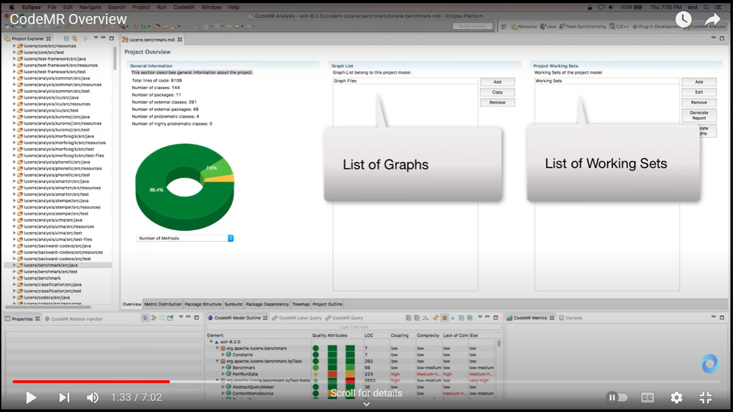

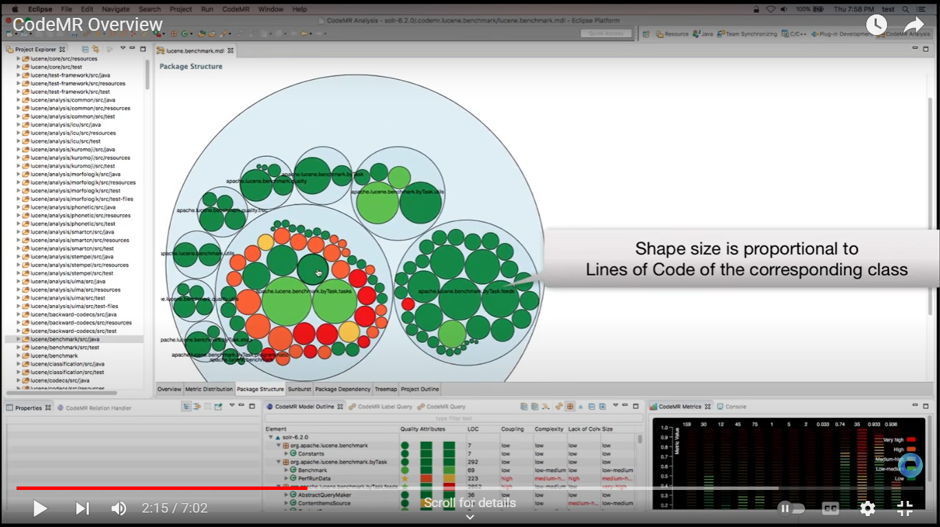

**Graphs**

**Spring Boot**

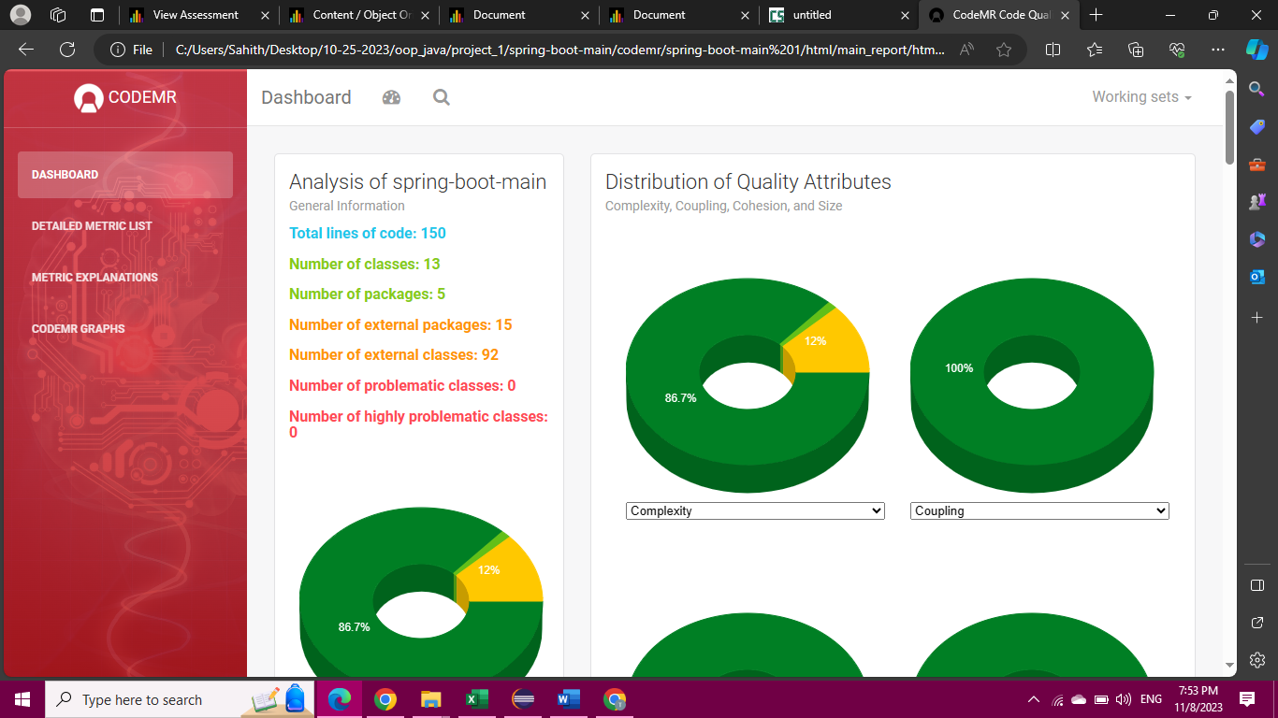

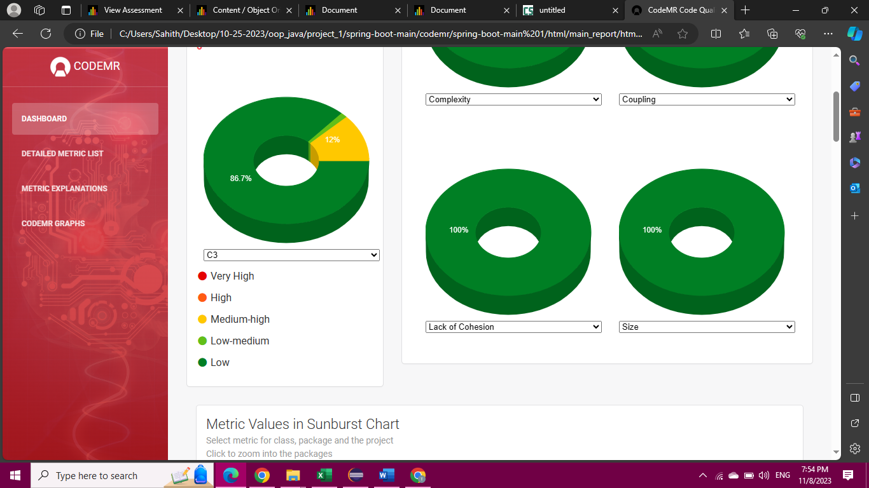

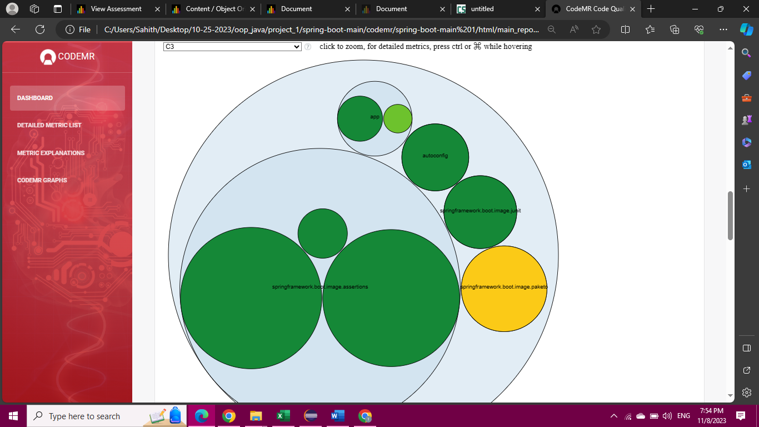

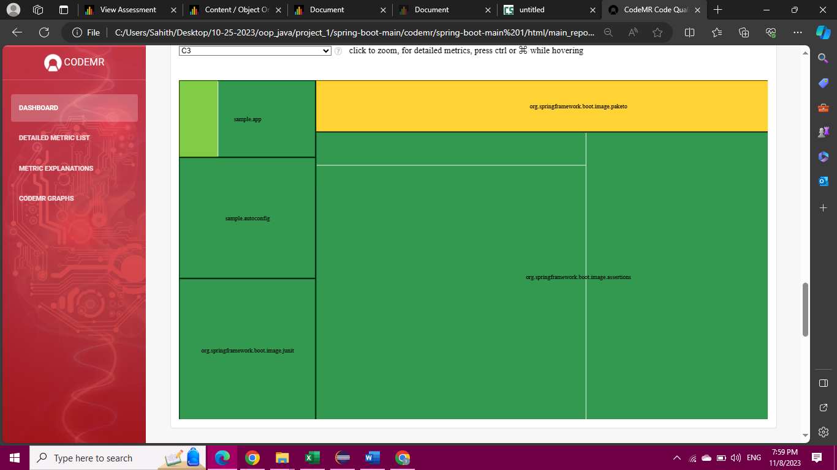

**JDBI Application**

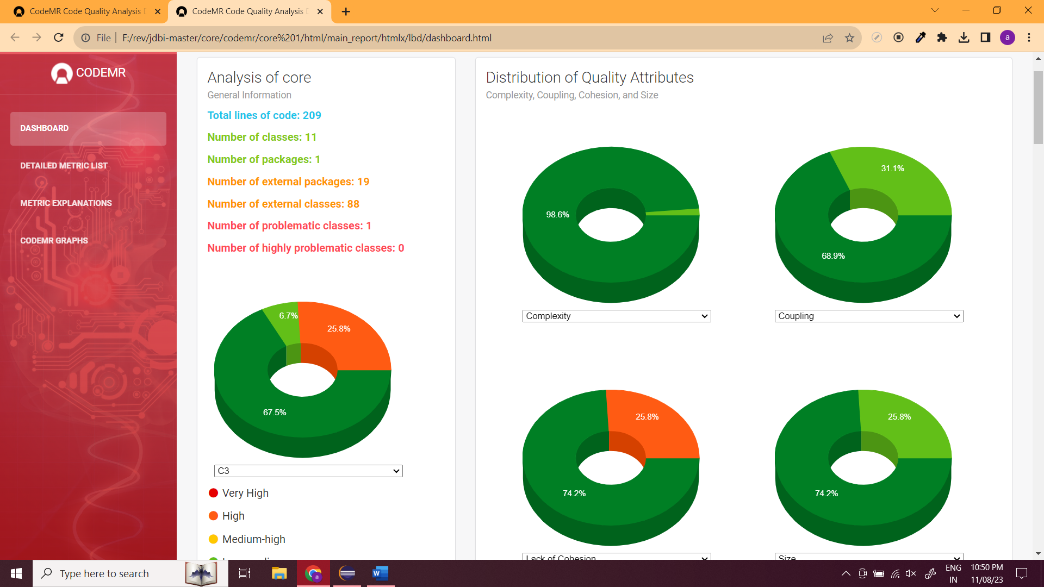

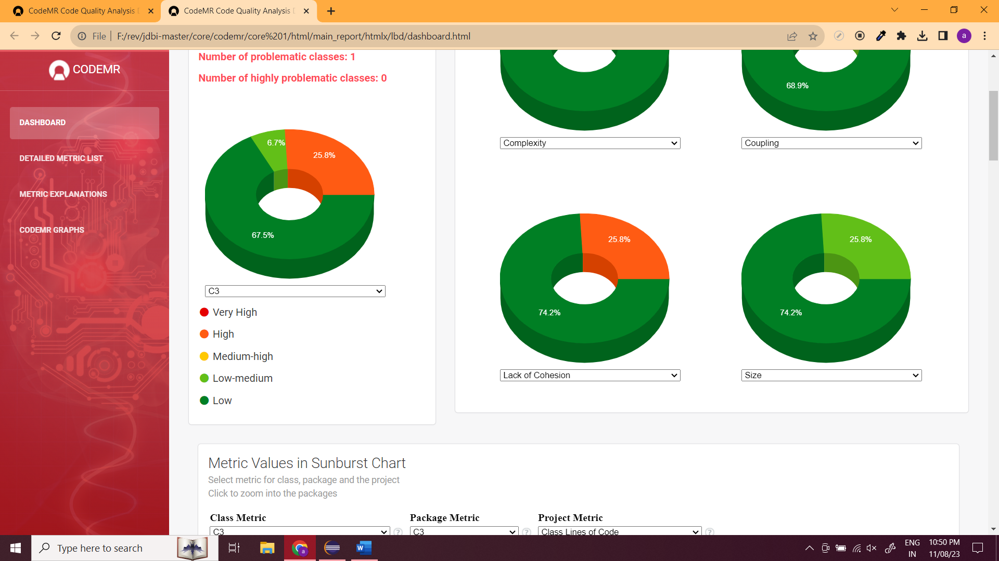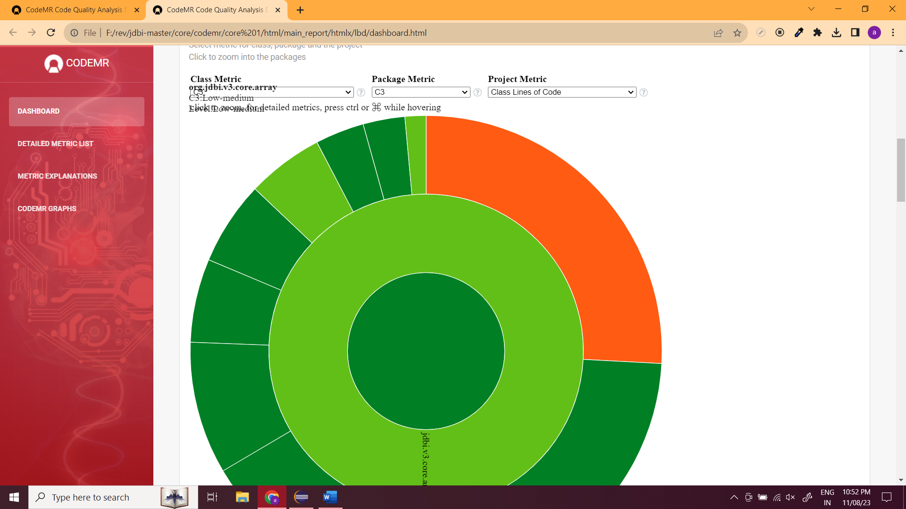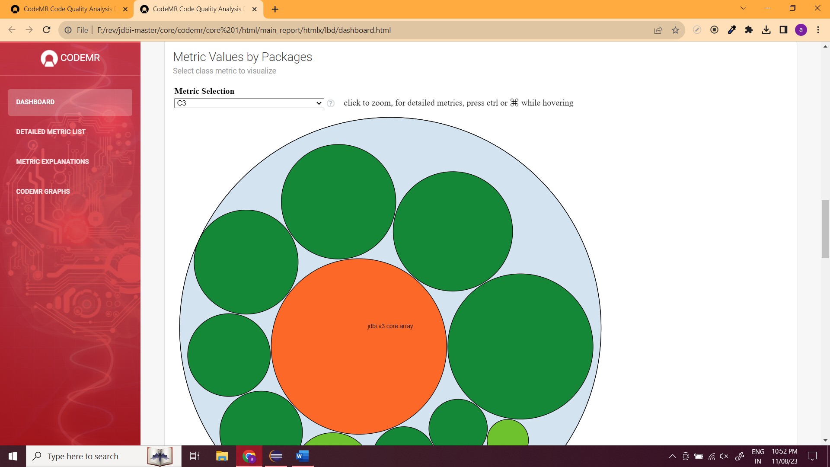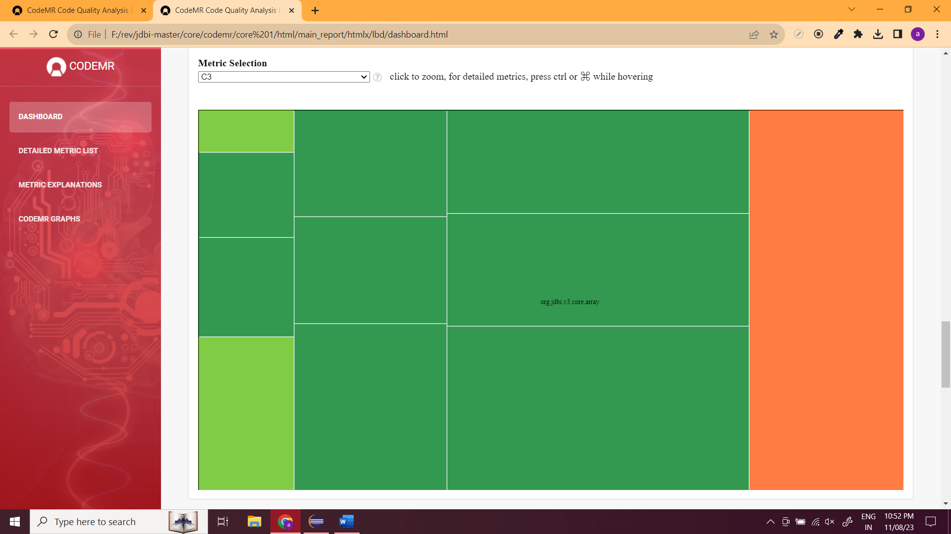

**Ehcache:**

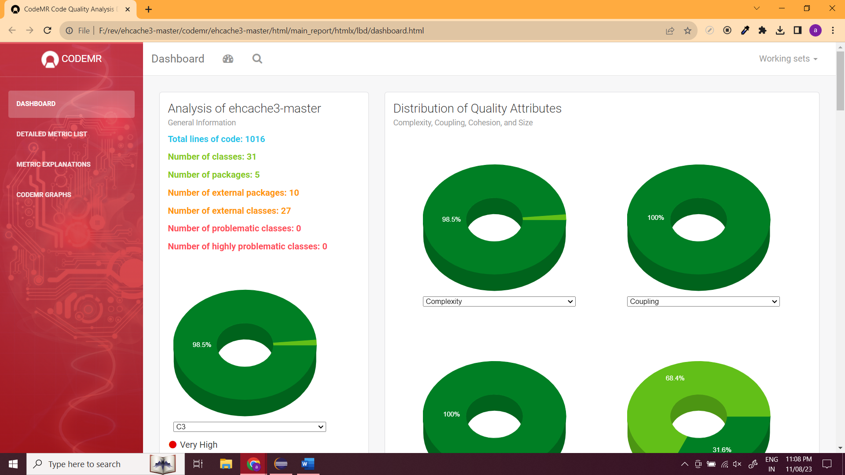

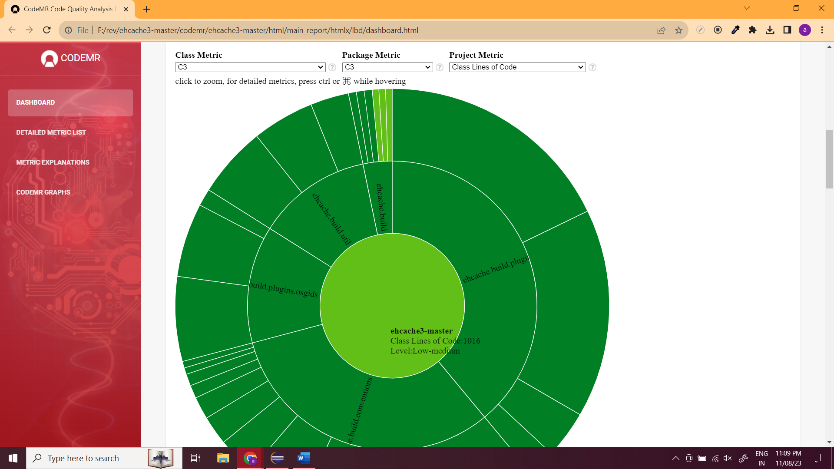

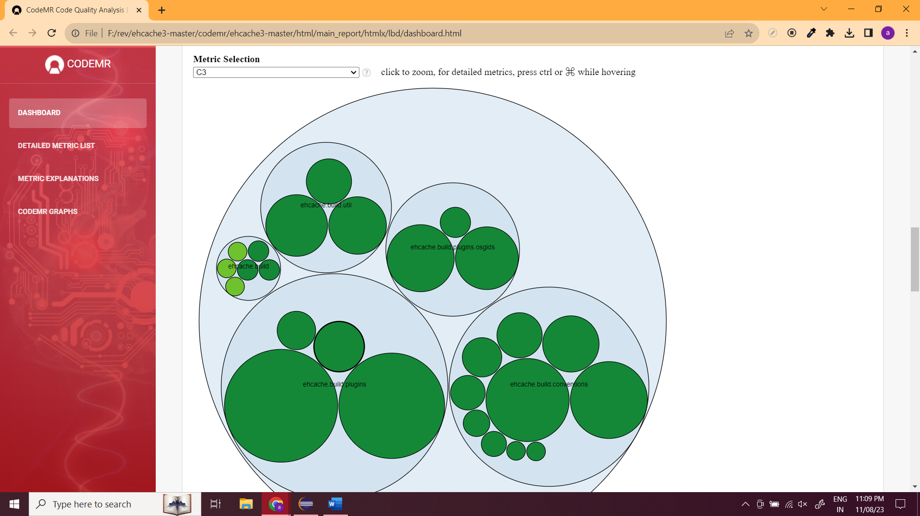

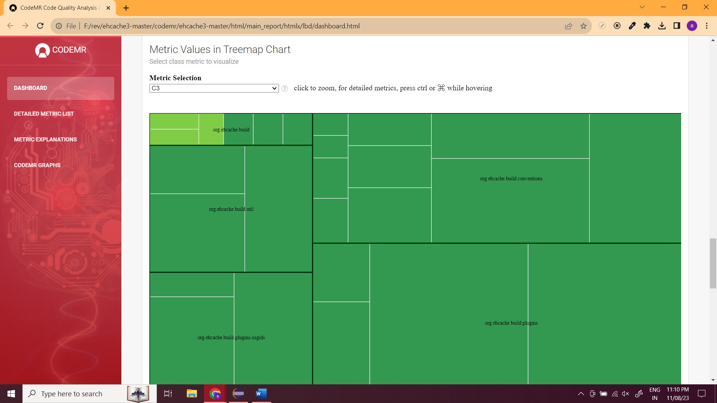

**OpenPDF**

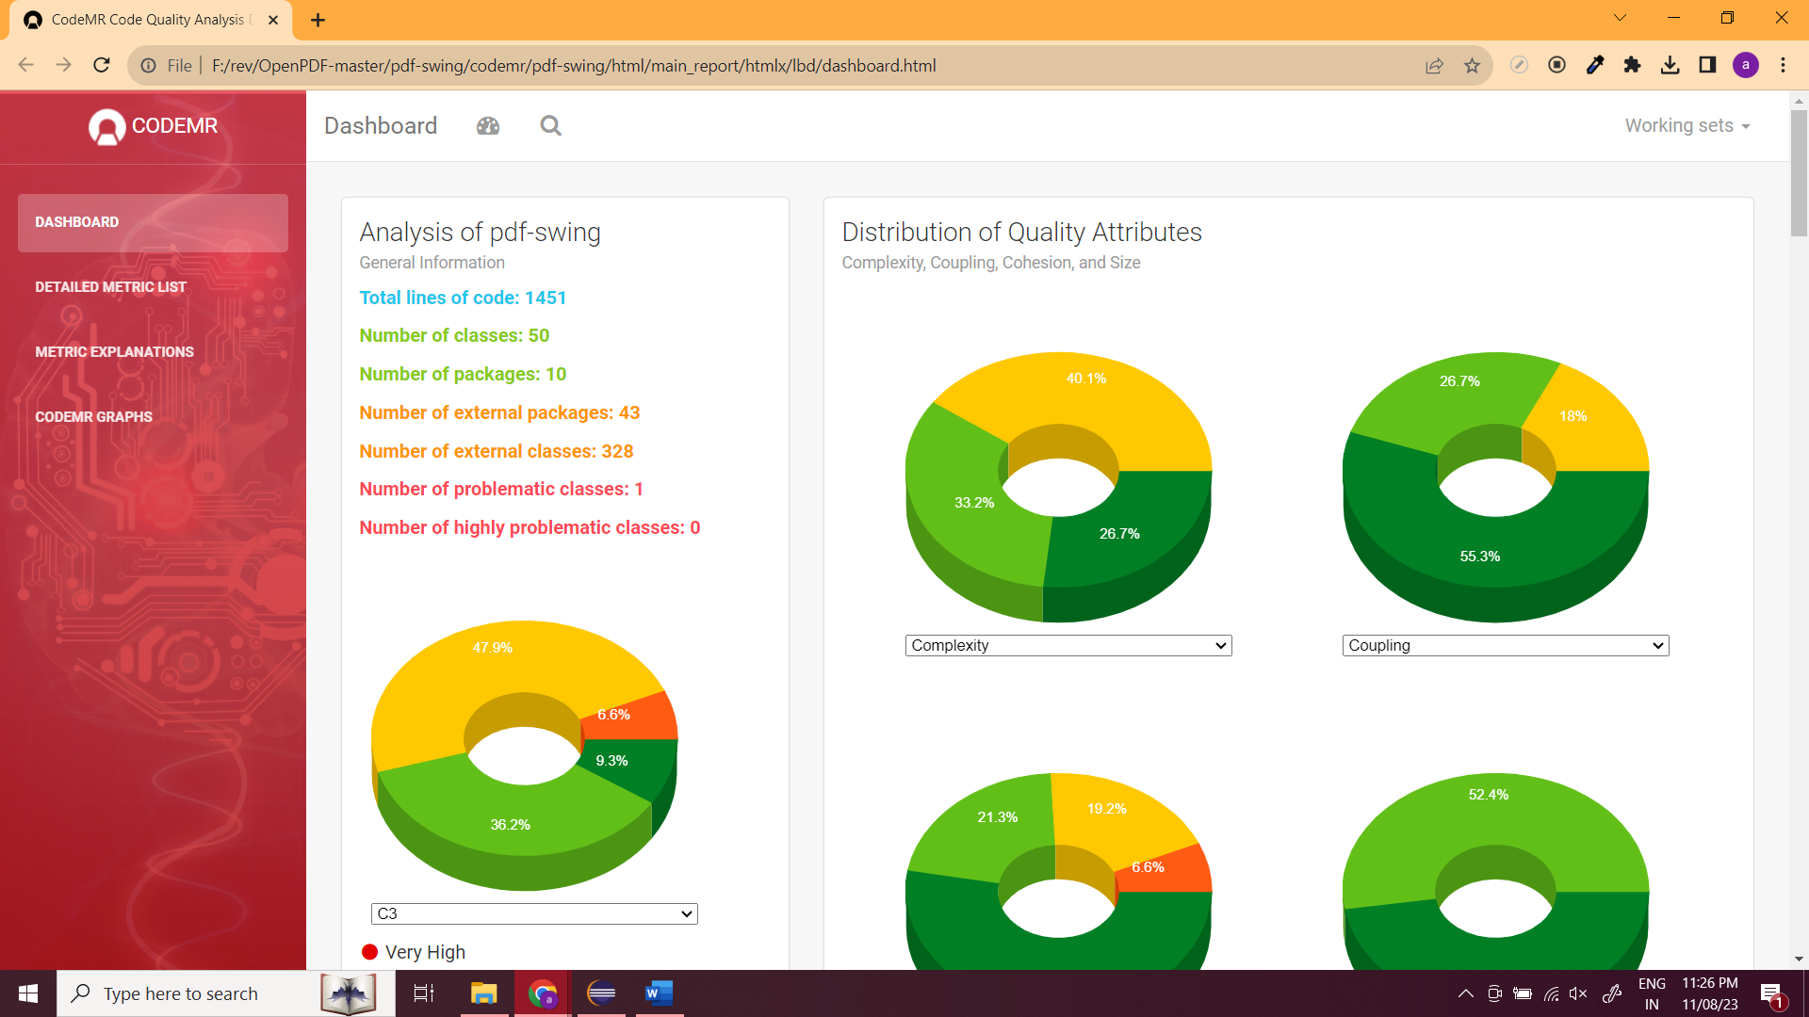

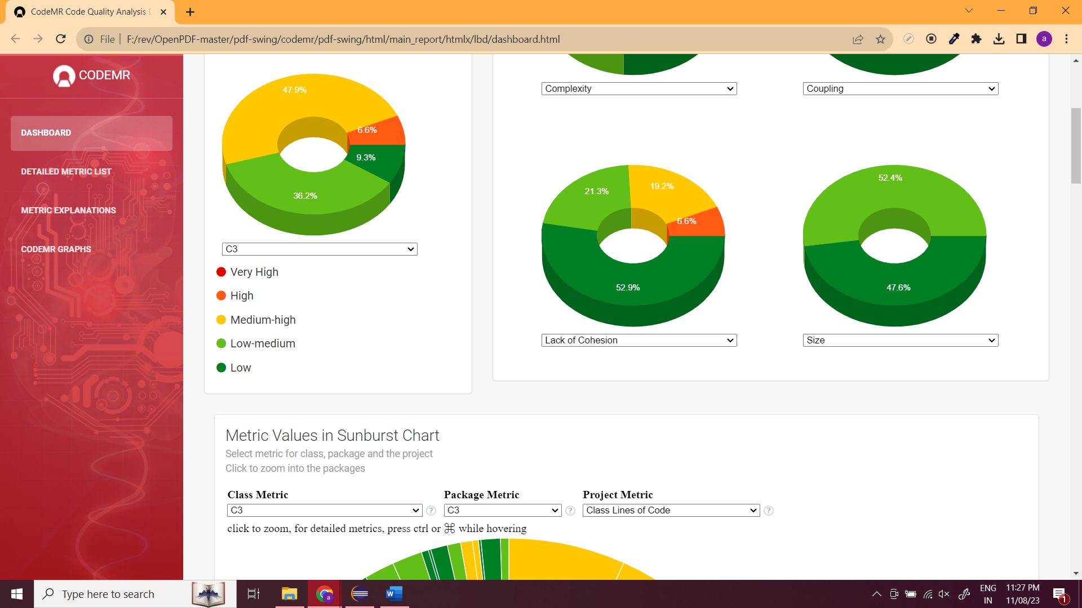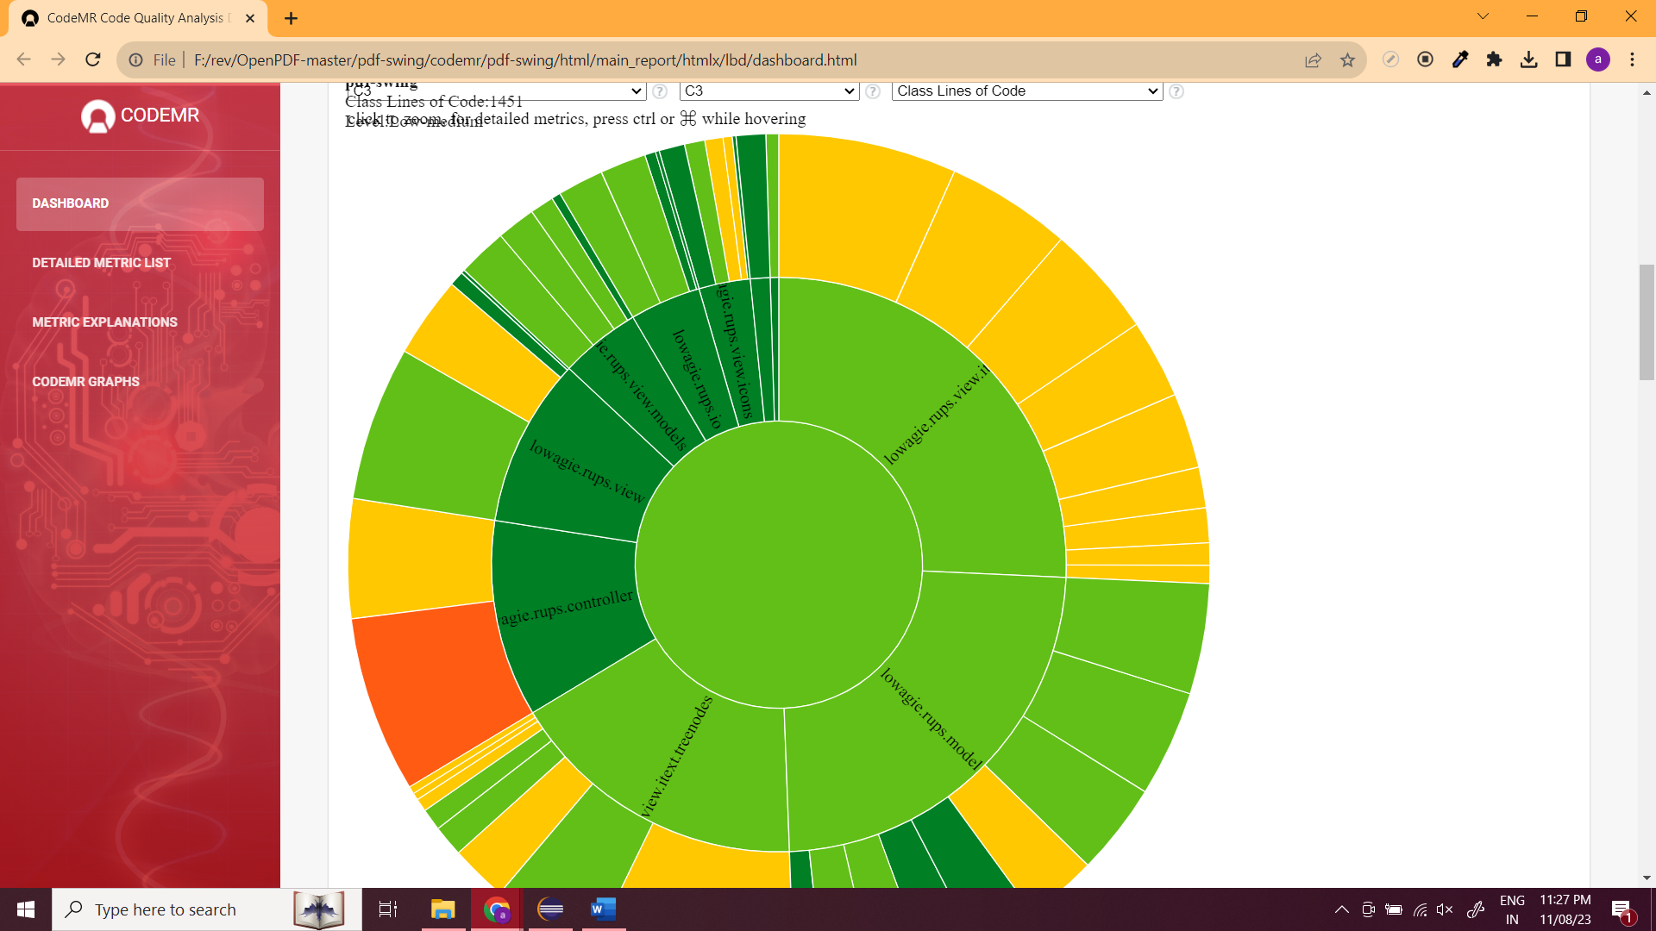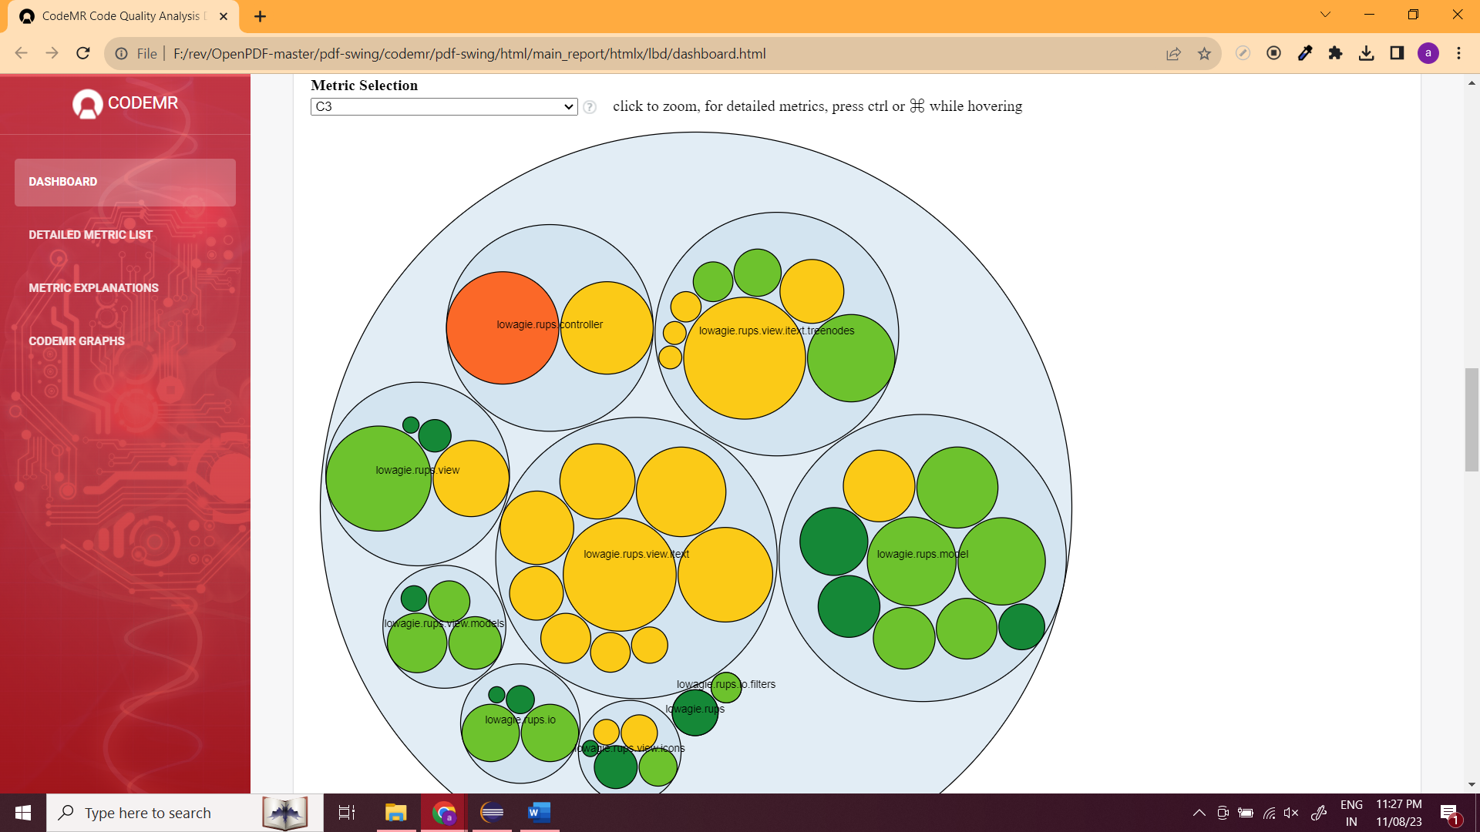

**Spring framework:**

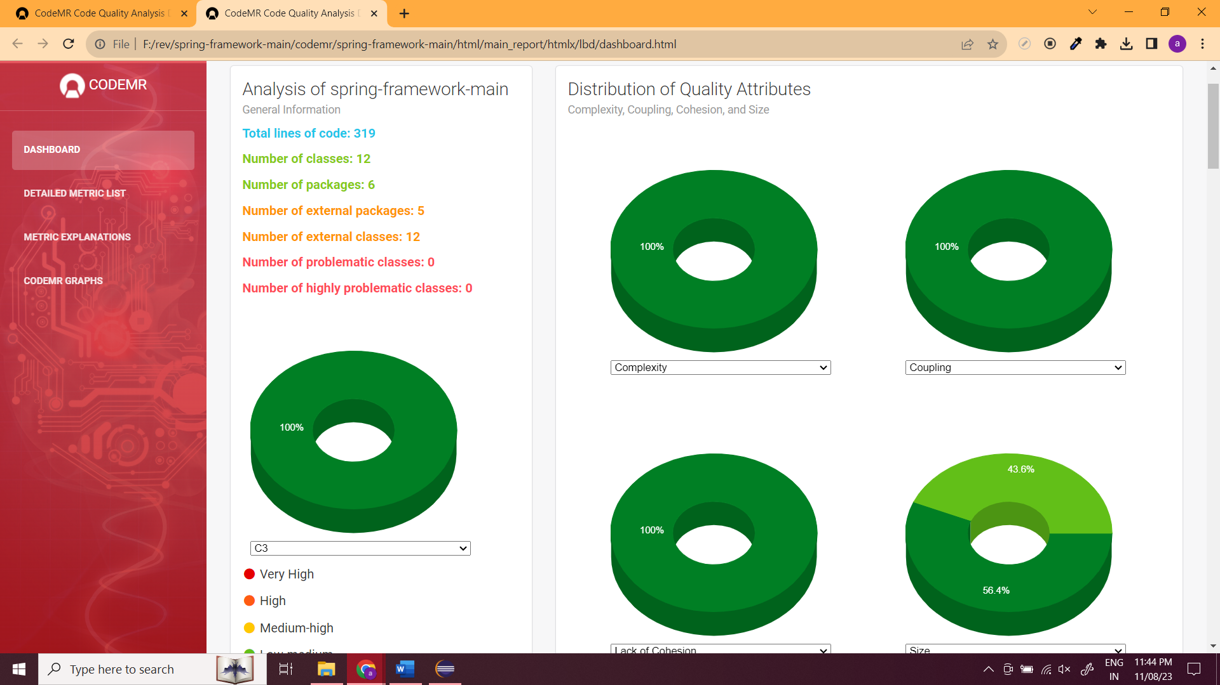

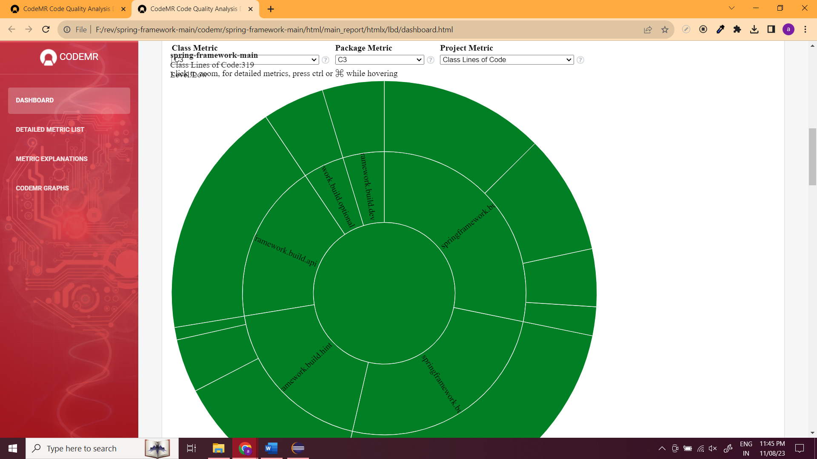

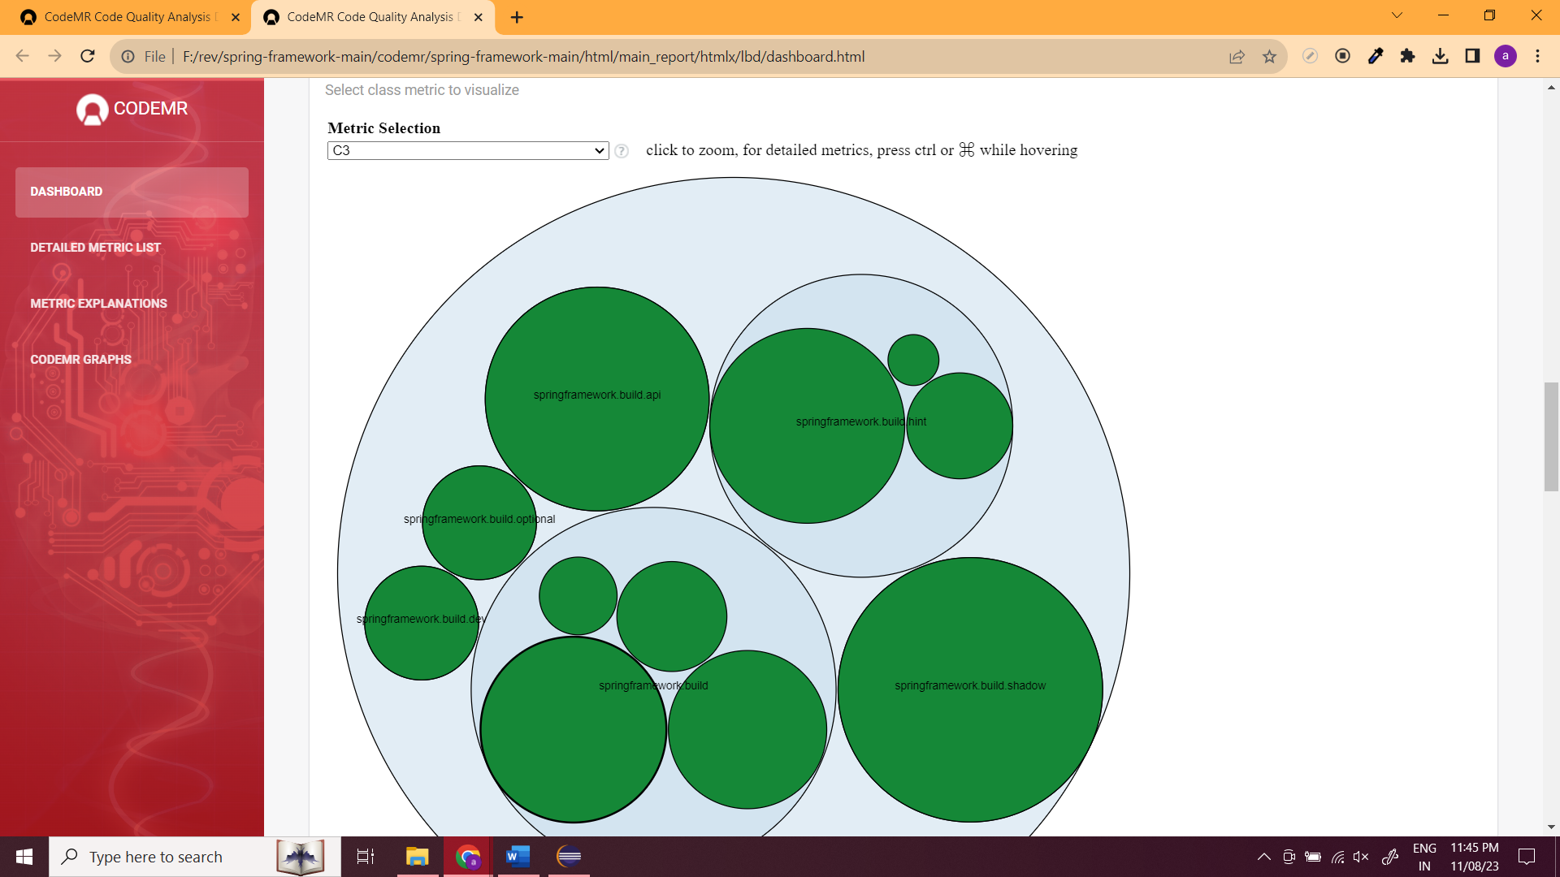

**Conclusions**

Larger classes, as indicated by higher values in the above metrics, can potentially lead to decreased software maintainability if not managed carefully.

Properly managing the metrics like WMC, DIT, NOC, CBO, RFC, and LCOM is crucial. For example, ensuring that classes have a reasonable number of methods, managing inheritance depth, minimizing coupling, and maintaining high cohesion can all contribute to improved maintainability, even in the presence of larger classes.

It's important to strike a balance between the benefits of abstraction and reuse (which can come with larger classes) and the potential complexity that may arise from larger class sizes. This balance is crucial for creating maintainable software systems.

**Reference**

Babu, G. V. R., Sailaja, D. P., & Srichandana, G. (2022). Strong coupled proximal points of cyclic coupled proximal mappings using Ck-class functions in S-metric spaces. *Filomat*, *36*(3), 933-944.

Batool, I., & Khan, T. A. (2022). Software fault prediction using data mining, machine learning and deep learning techniques: A systematic literature review. *Computers and Electrical Engineering*, *100*, 107886.